Proposal to Senior Leadership
  - AI-Supported Asynchronous Architecture Review Process

Appendix C

Input Prompt:
This is a change to the Mock system to provide a good example of what the agent can output.
The mock scenario is a move from Azure SQL to Oracle for ECRS v2.
The Mock Scenario is to fill in all user prompts as a software engineer would do in a real case.
Content:
ADR-001: Migrate MockSystem Database from Azure SQL to Oracle
Field | Value
ADR ID | ADR-001
Status | Proposed
Date | 2026-05-19
Authors | Riley L, Solution Architecture Team
Stakeholders | Tamatoa Engineering, DBA Team, Enterprise Architecture
Related Systems | MockSystem API, MockSystem.DataEF, MockSystem.DataRepositories, RelatedMockSystem (linked via Terraform)
Related ADRs | None
Decision Type | Strategic / Data / Infrastructure

1. Context
Current State
MockSystem is a .NET 10 Web API application managing the lifecycle of Electronic Navigational Charts (ENCs). The system records and audits production steps for new or updated ENCs.
The current data layer consists of:
- MockSystem.DataEF — Entity Framework Core with Microsoft.EntityFrameworkCore.SqlServer (v10.0.8) targeting Azure SQL Database
- MockSystem.DataRepositories — Repository pattern using Microsoft.EntityFrameworkCore (v10.0.8) with Polly retry policies
- Azure SQL Database — provisioned per environment (Dev, UAT, Pre, Live) via Terraform (Terraform/SQL/)
- Azure AD authentication — service principals created per environment for App Service managed identity access
- DACPAC deployments — schema managed via MockSystem.Database SQL project
The MockSystem API connects to Azure SQL via private endpoints, using EF Core as the ORM. The database naming convention is RelatedMockSystem-{env}-MockSystem-database. User provisioning is handled via SQL scripts that create Azure AD external provider users with db_owner permissions.
Constraints
- Oracle licensing costs must be approved by procurement
- Migration must not disrupt ongoing ENC production workflows
- Existing Terraform IaC must be updated or replaced for Oracle provisioning
- Oracle does not have native Azure PaaS offering — requires Oracle Cloud Infrastructure (OCI) or Azure VM hosting
- EF Core Oracle provider (Oracle.EntityFrameworkCore) has feature parity gaps with the SQL Server provider
Drivers
- Corporate mandate to consolidate on Oracle as the strategic enterprise database platform
- Alignment with wider UKHO data strategy for shared Oracle RAC infrastructure
- Reduction of Azure SQL licensing costs across the estate
Risks (if we do nothing)
- Continued divergence from enterprise database standard
- Increased cost of maintaining Azure SQL alongside Oracle estate
- Missed opportunity to leverage existing DBA team Oracle expertise

2. Change Description
What is Changing
The MockSystem data layer will be migrated from Azure SQL Database to Oracle Database. This affects:
Component | Change
MockSystem.DataEF | Replace Microsoft.EntityFrameworkCore.SqlServer with Oracle.EntityFrameworkCore
MockSystem.DataRepositories | Update any SQL Server-specific query syntax (e.g., OFFSET FETCH, temporal tables)
MockSystem.Database (DACPAC) | Replace with Oracle DDL migration scripts
Terraform/SQL/ | Replace Azure SQL provisioning with Oracle infrastructure (OCI or Azure VM)
Pipeline YAML | Update deployment steps for Oracle schema migrations
Connection strings | Update App Configuration and Key Vault entries
Azure AD authentication | Replace with Oracle wallet or certificate-based authentication
Scope
- MockSystem.DataEF — full rewrite of DbContext configuration and entity mappings
- MockSystem.DataRepositories — review and update all raw SQL / EF LINQ that uses SQL Server-specific features
- MockSystem.DataServices — no change expected (abstracts data access)
- MockSystem.API — connection string configuration change only
- Terraform — new Oracle infrastructure module required
- MockSystem.API-Client — no change (HTTP layer only)
- Testing — all integration tests require re-targeting to Oracle
Operational Impact
- DBA team must onboard Oracle monitoring for MockSystem
- Existing Azure SQL alerting rules become redundant
- Backup and disaster recovery strategy must be redesigned for Oracle

3. Decision
We will migrate the MockSystem database from Azure SQL Database to Oracle Database, replacing the EF Core SQL Server provider with the Oracle provider and re-provisioning data infrastructure on the corporate Oracle platform.

4. Reasoning
Benefits
- Aligns with enterprise database consolidation strategy
- Leverages existing Oracle DBA team expertise and tooling
- Reduces Azure SQL licensing spend
- Enables use of shared Oracle RAC for high availability
Trade-offs
- Loss of Azure PaaS benefits (auto-patching, serverless scaling, built-in geo-replication)
- Oracle EF Core provider is less mature than the SQL Server provider
- Increased infrastructure management overhead (if VM-hosted)
- Team must upskill on Oracle-specific syntax and tooling
Assumptions
- Oracle infrastructure will be provisioned and available before migration begins
- Oracle.EntityFrameworkCore provider supports all EF Core features currently used by MockSystem
- DBA team has capacity to support an additional Oracle instance
Alternatives Considered
Alternative | Reason Rejected
Stay on Azure SQL | Does not align with enterprise database strategy; continued licensing divergence
Migrate to PostgreSQL (Azure Database for PostgreSQL) | Not on the approved enterprise database list; would still require separate DBA support
Use Oracle on Azure VM (IaaS) | Considered as an interim option but adds VM management overhead; may be used as stepping stone
Migrate to Oracle Autonomous Database (OCI) | Network connectivity between Azure and OCI adds latency and complexity; cross-cloud egress costs
Cost/Risk Analysis
Factor | Azure SQL (Current) | Oracle (Proposed)
Licensing | Azure SQL DTU/vCore pricing | Oracle Enterprise License (existing agreement)
Operational | Managed PaaS, minimal DBA input | Requires dedicated DBA support
Availability | 99.99% SLA (Business Critical) | RAC-dependent; [TODO: confirm SLA]
Migration Risk | N/A | Medium — schema and query translation required

5. Architecture Practice Alignment
Practice Area | Alignment
Security | Oracle Wallet/TDE encryption aligns with data-at-rest requirements; Azure AD auth replaced with certificate-based auth
Integration | No change to API contract; downstream consumers unaffected
Cloud Strategy | Partial divergence — moves data tier off Azure PaaS; aligns with hybrid-cloud strategy if OCI interconnect used
Resilience | Oracle RAC provides HA; DR strategy must be redesigned (currently geo-replication)
Data Governance | No change to data classification; MockSystem data remains internal-only

6. Impact Assessment
Positive Outcomes
- Single enterprise database platform across UKHO
- Reduced total Azure consumption costs
- Access to Oracle-specific features (partitioning, advanced compression)
- Leverages existing DBA team and Oracle tooling (Enterprise Manager, Data Guard)
Risks
- Oracle EF Core provider may not support all LINQ translations currently used
- Migration bugs in schema translation (data types, constraints, triggers)
- Performance regression if Oracle indexing strategy differs from Azure SQL
- Team learning curve on Oracle-specific debugging and performance tuning
- Temporary loss of automated geo-replication during transition
Technical Debt Introduced
- Dual-database support during phased migration (both Azure SQL and Oracle active)
- Temporary feature toggles to route traffic between old and new data layers
- Legacy DACPAC project retained until Oracle migration validated in production
Operational Considerations
- DBA team must add MockSystem Oracle instance to monitoring rotation
- New alerting rules required (Oracle Enterprise Manager or Prometheus exporter)
- Backup schedule and retention policy must be agreed with DBA team
- Runbooks in wiki (Support/System-Support/MockSystem.md) must be updated
- Incident support documentation (Support/Incident-Support/MockSystem.md) needs Oracle-specific troubleshooting

7. Diagrams
Current State
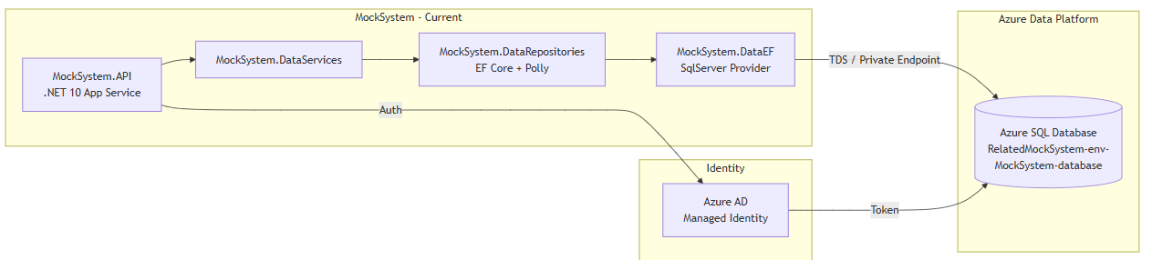
Proposed State
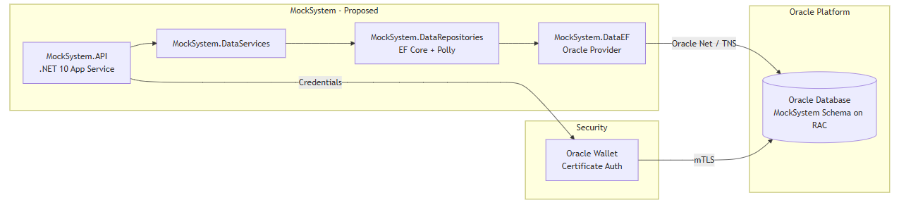
Data Flow / Sequence
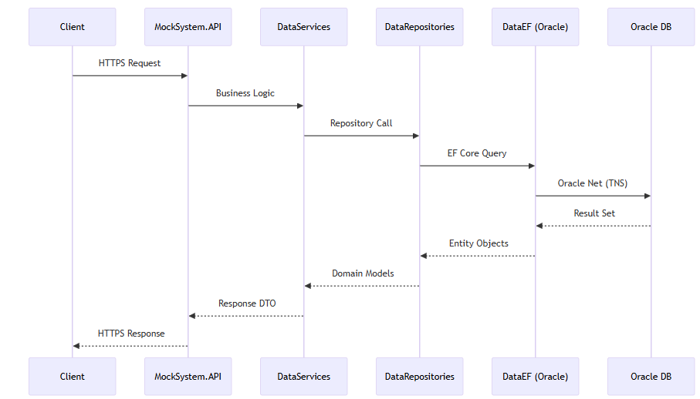

8. Implementation Notes
Area | Notes
Delivery Approach | Phased rollout: Dev → UAT → Pre → Live with feature toggle to switch data providers
Migration Plan | 1. Provision Oracle infrastructure 2. Port schema (DDL) 3. Swap EF provider 4. Data migration (ETL) 5. Validate 6. Cutover
Rollback Strategy | Feature toggle reverts to Azure SQL; Azure SQL retained read-only for 30 days post-cutover
Dependencies | Oracle infrastructure provisioned by DBA team; Oracle.EntityFrameworkCore NuGet package validated for .NET 10; Network connectivity (ExpressRoute or VPN) confirmed

9. Questions / Open Items
Question | Owner | Status
Does Oracle.EntityFrameworkCore support all EF Core 10 features used in MockSystem? | Engineering Team | Open
What is the Oracle RAC SLA for the shared platform? | DBA Team | Open
Will Oracle be hosted on-premises, Azure VM, or OCI? | Enterprise Architecture | Open
What is the network path from Azure App Service to Oracle? | Infrastructure Team | Open
How will schema migrations be managed post-DACPAC? (Flyway? Liquibase?) | Engineering Team | Open
What is the data migration strategy for existing production data? | DBA Team / Engineering | Open
Are there any EF LINQ queries using SQL Server-specific functions (e.g., OPENJSON, STRING_AGG)? | Engineering Team | Open

10. Sign-Offs
Role | Name | Status | Date
Enterprise Architect |  | Pending
Security Architect |  | Pending
Product Owner |  | Pending
Technical Lead |  | Pending
DBA Lead |  | Pending

11. References
- MockSystem Architecture Documentation
- MockSystem Dependencies
- MockSystem Service Breakdown (Wiki)
- MockSystem Terraform SQL Scripts
- [TODO: Link to Enterprise Database Strategy document]
- [TODO: Link to Oracle licensing agreement]
- [TODO: Link to ADO Epic/Feature for this work]

